**Test Case 1: Editing a day in a trip**

|  |  |
| --- | --- |
| **ID** | 1 |
| **Title** | Edit Day |
| **Pre-Conditions** | Set trip ID to 1 and click itinerary control |
| **Test Steps** | 1. Select a day in the datagridview      1. Click the “Edit Day” button to open the Edit form      1. Make changes to data   Original Edited     1. Click Edit Day, on the Edit form |
| **Expected Results** | Message box with the message “Day Edited” |

**Test Case 2: Adding a day to a trip**

|  |  |
| --- | --- |
| **ID** | 2 |
| **Title** | Add New Day |
| **Pre-Conditions** | Set Trip ID to 1 and click Itinerary Control |
| **Test Steps** | 1. Click the “Add New Day” Button      1. Fill form with data      1. Click Add Day button 2. Click the Reload days button |
| **Expected Results** | New row in datagridview |

**Test Case 3: Add Day Below Selected**

|  |  |
| --- | --- |
| **ID** | 3 |
| **Title** | Add Day Below Selected |
| **Pre-Conditions** | Set Trip ID to 1 and click Itinerary Control |
| **Test Steps** | 1. Select a row or cell in the datagridview      1. Click the “Add Day Below Selected” button 2. Fill the “Add Below Selected” form with data      1. Click the “Add Day” button 2. Click the “Reload Days” button |
| **Expected Results** | Adds a new row of data below the selected row  Changes the day_id for all rows below the added row |

**Test case 4: Customer’s Application Form**

Assumptions:

* no minimum age to cruise
* there's only adult and senior(>64 years old) pricing
* special price will be entitled to purchasing tickets 20days or less prior to departure date
* payment of cruise tickets are done by contractor, overall payment data will not be stored in database
* tax is included in overall calculation

|  |  |
| --- | --- |
| **ID** | 4 |
| **Title** | Add 1 x Customer(number of guest 0) |
| **Pre-Conditions** | All fields must be filled/selected before proceeding to the next form:   * Cruise Itinerary = 7-DAY PASSAGE FROM Willow Creek TO Dundee * Number of Guest = 0 * All textboxes * Date Of Birth = May 4, 1990 |
| **Test Steps** | 1. Fill/select every fields, Figure 4.1 2. Click button “NEXT:STATEROOM >,” Figure 4.1 3. Select Ship Deck level, Figure 4.2 4. Choose cabin number, room colors are according to cabin type based on the legend, Figure 4.2 5. Click “GENERATE INVOICE” button, Figure 4.3 6. Click “EXIT” button to restart a new form, Figure 4.3 |
| **Expected Results** | * Customers Information will be inserted into database * Invoice generated displaying: * Passenger name * Itinerary name * Ship name * Departure date * Cabin number and type * Deck level * Total number of passengers * Price of per type of passenger * Overall cost(tax included) |

Figure 4.1. Main Form

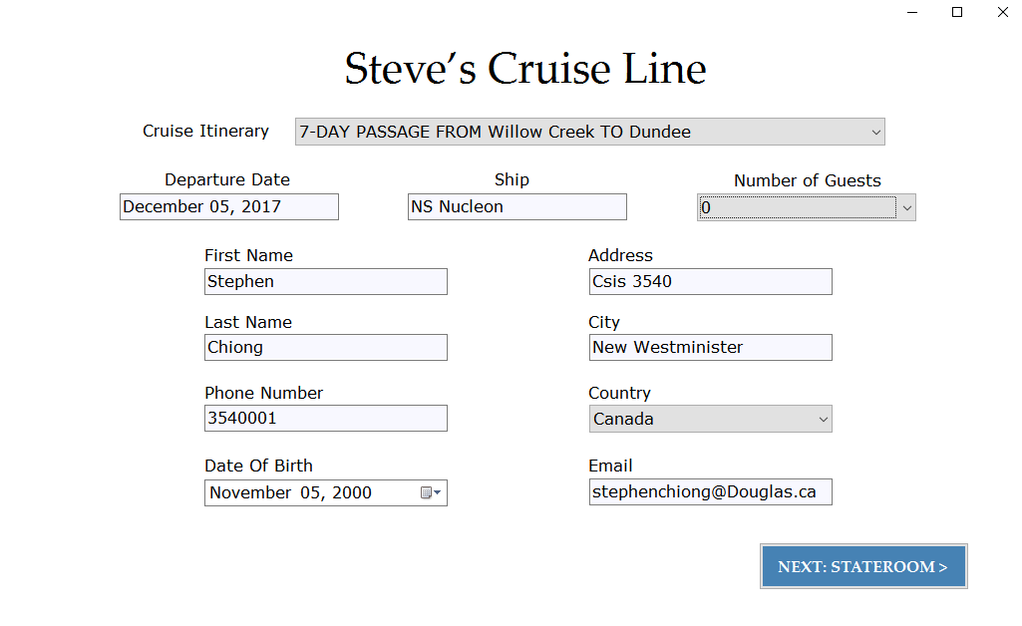

Figure 4.2. Stateroom

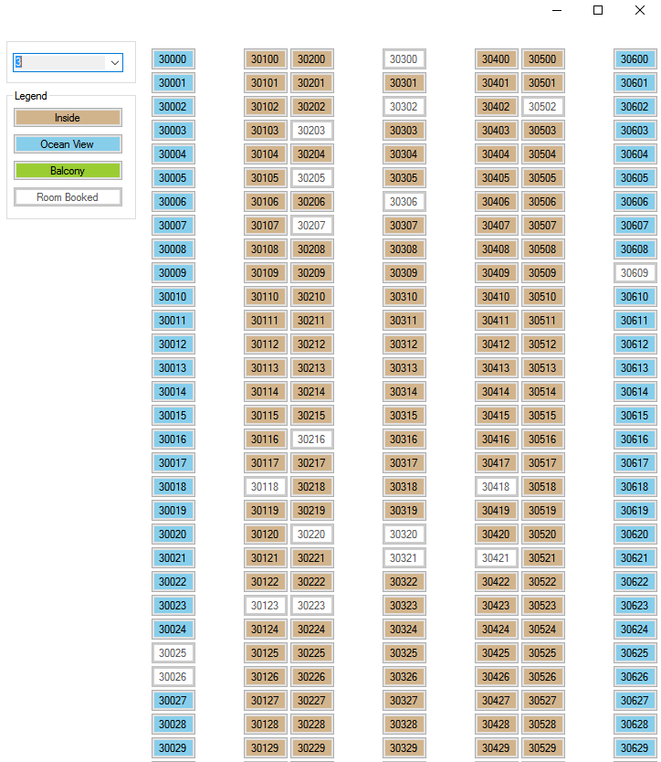

Figure 4.3. Invoice

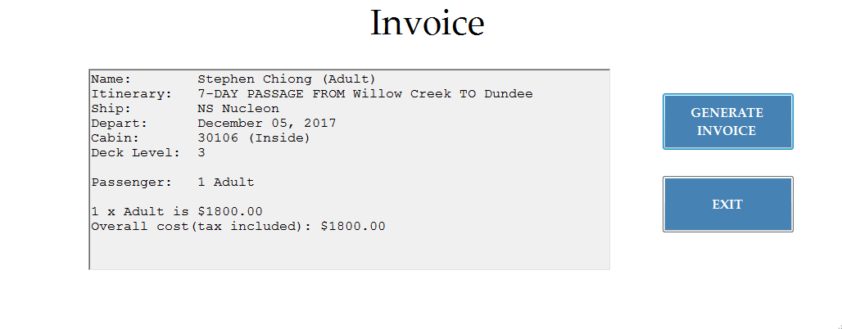

SQL database

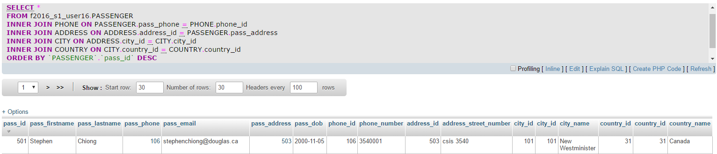

**Test Case 5: Error handling responds on Customer Application form**

|  |  |
| --- | --- |
| **ID** | 5 |
| **Title** | Error handling responds - fail to fill in any fields |
| **Pre-Conditions** | * Trying to proceed to next form without filling up all fields |
| **Test Steps** | 1. Click “NEXT:STATEROOM” button, Figure 5.1 2. Click “OK” on error box, Figure 5.1 3. Fill/select one field – City=New Westminster, Figure 5.2 4. Click “NEXT:STATEROOM” button, Figure 5.2 5. Click “OK” on error box, Figure 5.2 6. Fill/select all except one field, Figure 5.3 7. Click “NEXT:STATEROOM” button, Figure 5.3 |
| **Expected Results** | * Error box appear * Error prompt removed on one field (when it’s been filled) * Error box will appear even with one unfilled field |

Figure 5.1. Error box appear

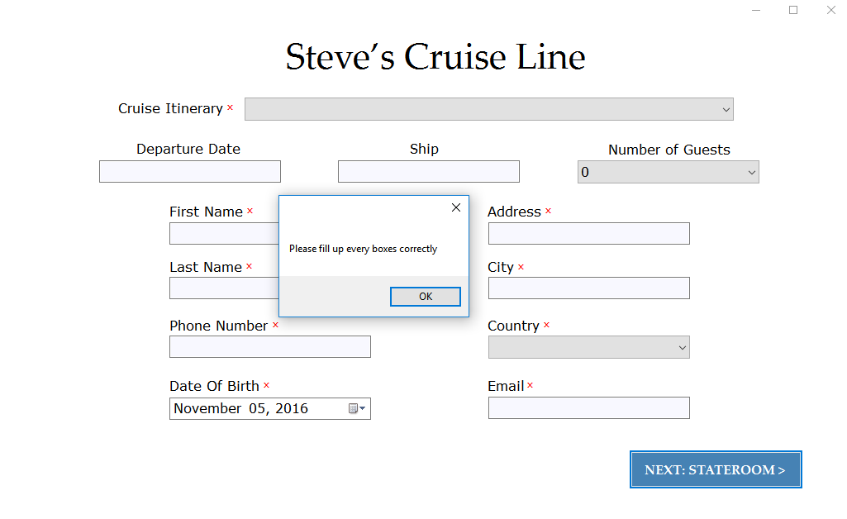

Figure 5.2. Error prompt removed on one field

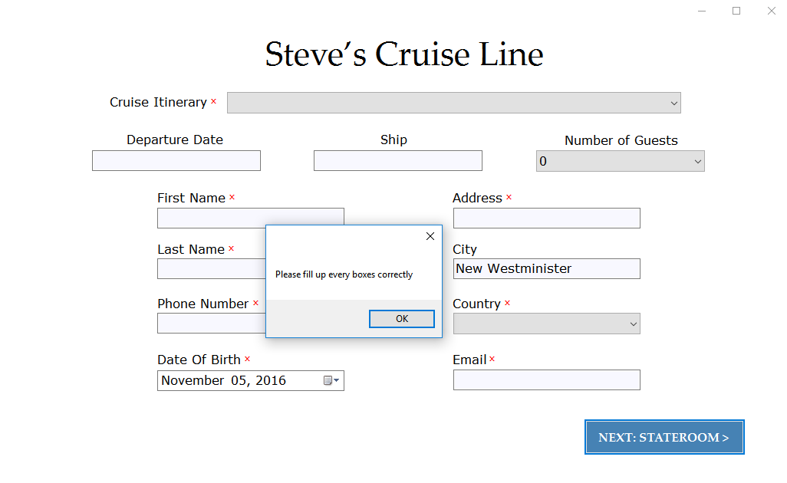

Figure 5.3. Error prompt removed on all except one field

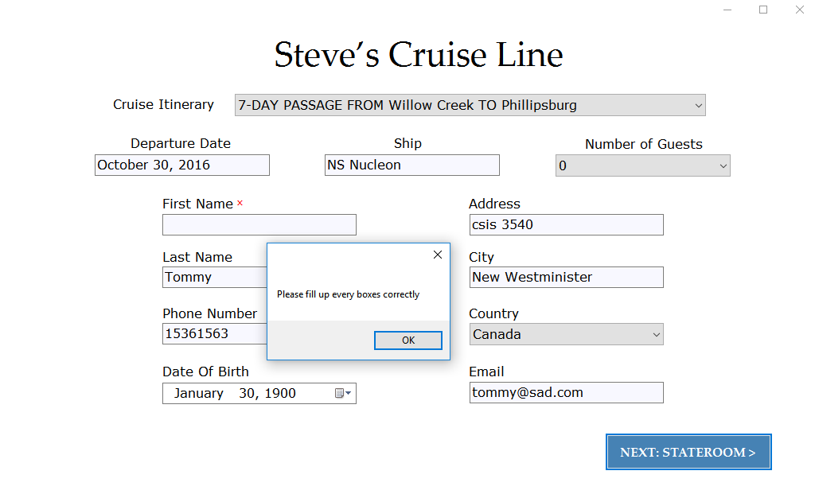

**Test Case 6 & 7: Billing**

|  |  |
| --- | --- |
| **ID** | 6 |
| **TITLE** | Billing Calculations |
| **PRE-CONDITIONS** | 1. System must be connected to the database. 2. Passenger must be a Bill Holder |
| **TEST STEPS** | 1. Enter Room number. For ex. Room number is 22 2. Click on “**Calculate Bill**” button. 3. To print out the bill , click on “**Print Displayed Bill**” button. |
| **EXPECTED RESULTS** | 1. Your bill will be calculated on the basis of items purchased by all the passengers in the room when you are onboard and the calculated total bill will be shown in the “textbox” on the screen along with the Bill Holder’s name and room number on the top of it. 2. A message in the message box “**Bill saved!**” tells that the bill is printed out successfully. |

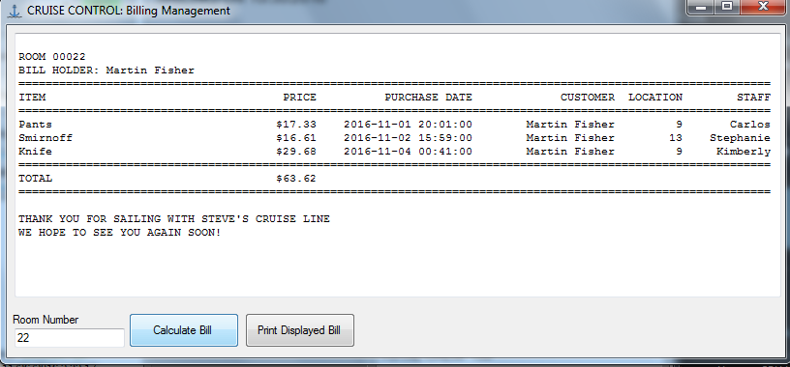

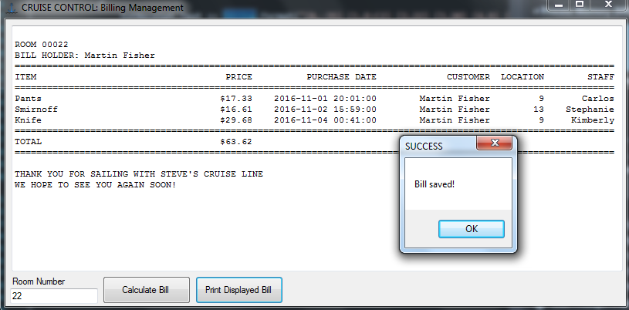

|  |  |
| --- | --- |
| **ID** | 7 |
| **TITLE** | Billing Calculations |
| **PRE-CONDITIONS** | 1. System must be connected to the database. 2. Passenger must be a Bill Holder. |
| **TEST STEPS** | 1. Enter Room number. For ex. Room number is 8. 2. Click on “**Calculate Bill**” button. 3. To print out the bill , click on “**Print Displayed Bill**” button. |
| **EXPECTED RESULTS** | 1. A message in the message box “**No passenger in the selected room!**” tells that there is no passenger staying in the given room and bill can be calculated only for the rooms having bill holders staying in them. 2. A message in the message box “**No bill loaded!**” shows that there is no bill to save or print out for the given room as there is no passenger in it. |

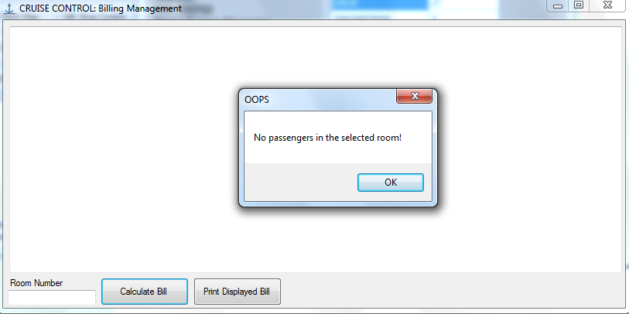

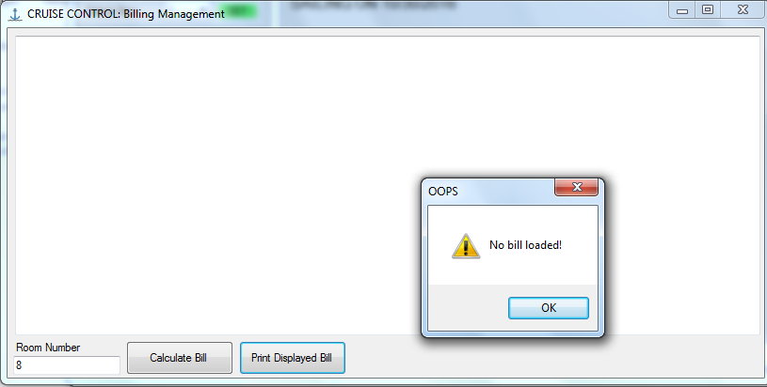

**Test Case 8 & 9: Inventory Control**

|  |  |
| --- | --- |
| **ID** | 8 |
| **TITLE** | Drink Inventory Control by Increasing and Decreasing its Stock. |
| **PRE-CONDITIONS** | 1. System must be connected to the database. 2. Passenger must click Increase or Decrease button. |
| **TEST STEPS** | 1. Select the Row of Drink Inventory value. 2. Enter the amount, you would like to increase or decrease the inventory. 3. Click the “Increase” button to increase the stock or Click the “Decrease” button to decrease the stock of Drinks. 4. To check the new updated Inventory Click “Show ship inventory” button. |
| **EXPECTED RESULTS** | Selected drink’s inventory value will be updated according to the amount entered. And it updates the original database at the backend. |

* Original Inventory data before any updating.

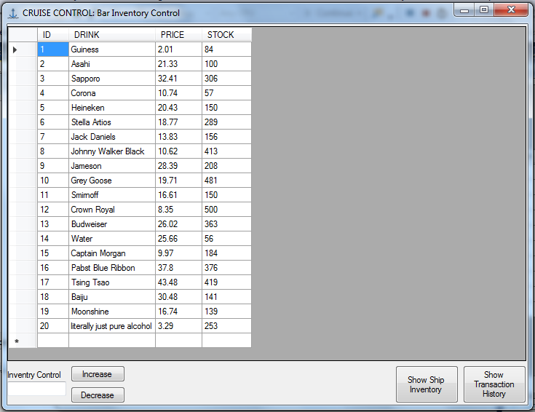

* Enter the value in inventory Control textbox. And select the drink from dataGridview and Click the Increase button to increase the Inventory.

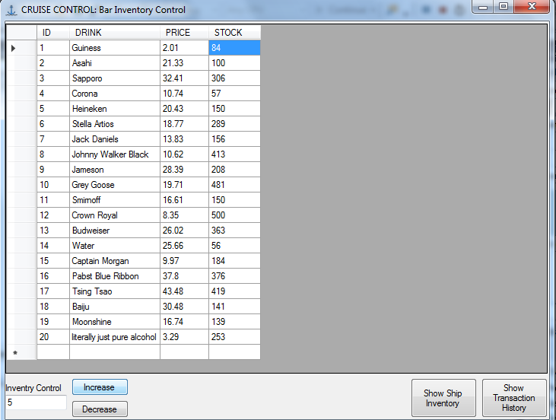

* New Inventory of Drinks has been updated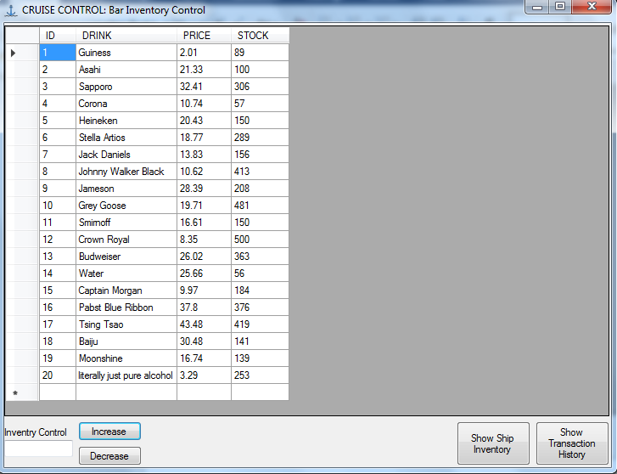

|  |  |
| --- | --- |
| **ID** | 9 |
| **TITLE** | Gifts Inventory Control by Increasing and Decreasing its Stock. |
| **PRE-CONDITIONS** | 1. System must be connected to the database. 2. Passenger must click Increase or Decrease button. |
| **TEST STEPS** | 1. Select the Row of Gifts Inventory value. 2. Enter the amount, you would like to increase or decrease the inventory. 3. Click the “Increase” button to increase the stock or Click the “Decrease” button to decrease the stock of Drinks. 4. To check the new updated Inventory Click “Show ship inventory” button. |
| **EXPECTED RESULTS** | Selected Gift’s inventory value will be updated according to the amount entered. And it updates the original database at the backend. |

* Original Inventory data before any updating.

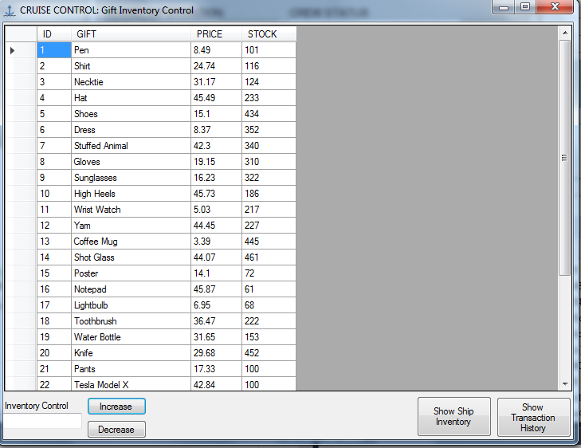

* Enter the value in inventory Control textbox. And select the drink from dataGridview and Click the Decrease button to decrease the Inventory.

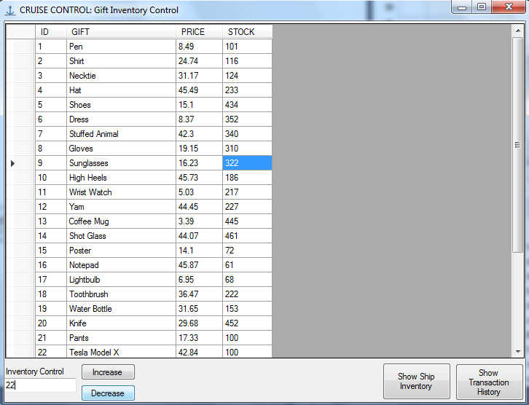

* New Inventory of Drinks has been updated

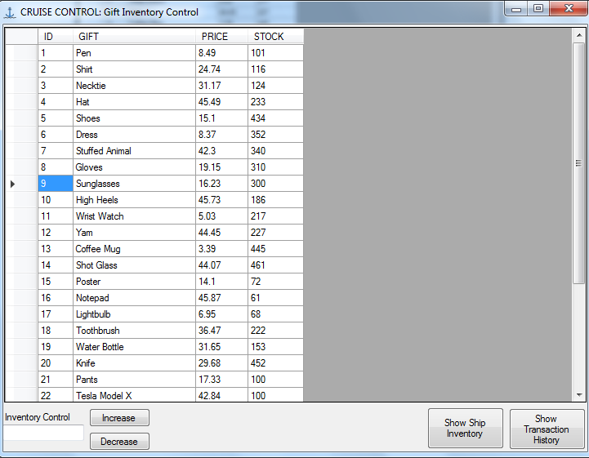

**Test Case 10: Ship Map**

|  |  |
| --- | --- |
| **ID** | 10 |
| **Title** | Display Map |
| **Pre-Conditions** | Select trip 1 in the previous form |
| **Test Steps** | 1. Select deck 3 in the combo box. Note the state of each room drawn 2. Select deck 1 in the combo box. Note the changes in the states of the rooms 3. Close the ship map and select trip 4 in the previous form 4. Select deck 3. Compare the rooms with the map from step 2 and 3 5. Book room 30000 in trip 1, deck 3. Refer to the booking section of the user manual 6. Find room 30000 by selecting trip 1 deck 3 again 7. Note the changes to the map |
| **Expected Results** | 1. The maps noted in the steps should differ from each other. 2. The map in step 1 should match the provided picture 3. Room 30000 should be disabled in step 8 when compared to the map in step 2 |

